***Part A***

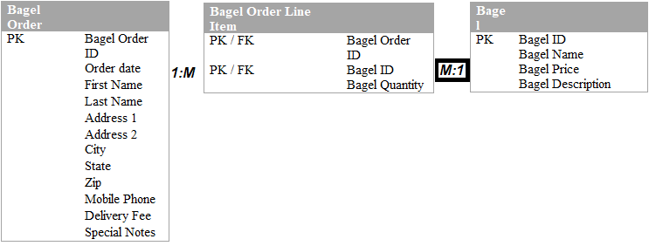

To adhere to the 2NF I started by grouping what was similar features like all the attributes with bagel types together or info that’s specific to the order of said bagel like order ID, date then went into bagel order. Finally Bagel OrderLine Items is used to make sure the customer’s order with the specific bagel is met.  Since there can be multiple items in one order the cardinatialy is 1 to many (bagel order - bagel items line) And since there can be many instance of the line items to one bagel

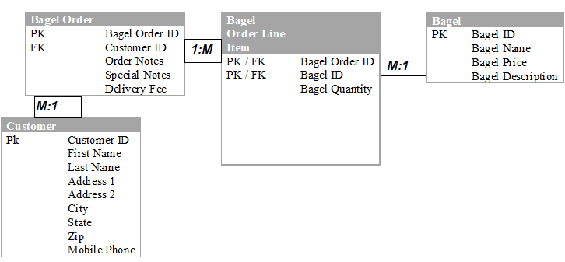

In order to get to the 3rd normal form more tables need to be populated. The bagel order table has been split by its primary keys creating a bagel order from which uses the foreign key of customer ID and also a customer table using customer ID as a primary key. These changes make the table cleaner and save memory and speed in the long term.

 Due to the addition of a table, we see a change of the cardinality previously seen. We see another many to one is created since many orders can belong to one customer. We all have our favorite coffee orders in the morning over the course of time creating hundreds of orders but however we’re still just one customer and that won’t change however the amount orders or contents of orders can

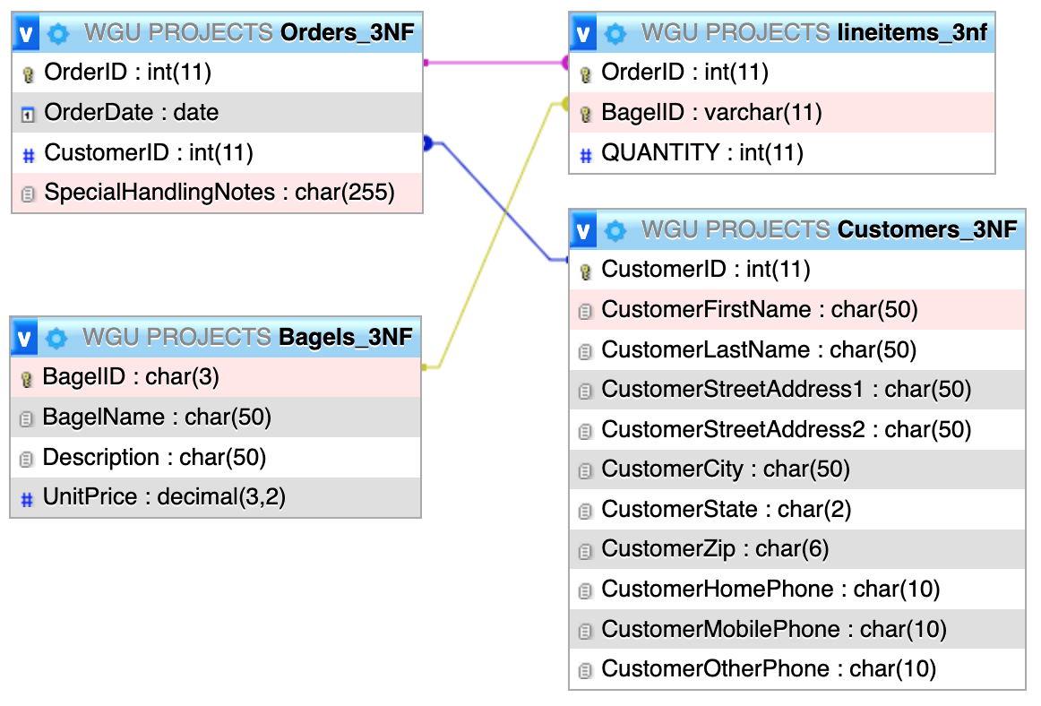

***Part B:***

***CREATION***

***SQL:*** CREATE TABLE `Coffee` (

`coffee_id` int(11) NOT NULL,

`shop_id` int(11) NOT NULL,

`supplier_id` int(11) NOT NULL,

`coffee_name` varchar(30) DEFAULT NULL,

`price_per_pound` decimal(5,2) DEFAULT NULL

) ALTER TABLE `Coffee`

ADD PRIMARY KEY (`coffee_id`),

ADD KEY `shop_id` (`shop_id`),

ADD KEY `supplier_id` (`supplier_id`);

ALTER TABLE `Coffee`

MODIFY `coffee_id` int(11) NOT NULL AUTO_INCREMENT;

ALTER TABLE `Coffee`

ADD CONSTRAINT `coffee_ibfk_1` FOREIGN KEY (`shop_id`) REFERENCES `Coffee_Shop` (`shop_id`),

ADD CONSTRAINT `coffee_ibfk_2` FOREIGN KEY (`supplier_id`) REFERENCES `Supplier` (`supplier_id`);

***SQL:*** CREATE TABLE `Coffee_Shop` (

`shop_id` int(11) NOT NULL,

`shop_name` varchar(50) DEFAULT NULL,

`city` varchar(50) DEFAULT NULL,

`STATE` varchar(2) DEFAULT NULL

) ALTER TABLE `Coffee_Shop`

MODIFY `shop_id` int(11) NOT NULL AUTO_INCREMENT;

ALTER TABLE `Coffee_Shop`

ADD PRIMARY KEY (`shop_id`);

ALTER TABLE `Coffee_Shop`

MODIFY `shop_id` int(11) NOT NULL AUTO_INCREMENT;

***SQL:*** CREATE TABLE `Employee` (

`employee_id` int(11) NOT NULL,

`first_name` varchar(30) NOT NULL,

`last_name` varchar(30) NOT NULL,

`hire_date` date NOT NULL,

`job_title` varchar(30) NOT NULL,

`shop_id` int(11) NOT NULL

)

ALTER TABLE `Employee`

ADD PRIMARY KEY (`employee_id`);

ALTER TABLE `Employee`

MODIFY `employee_id` int(11) NOT NULL AUTO_INCREMENT;

***Supplier:***

***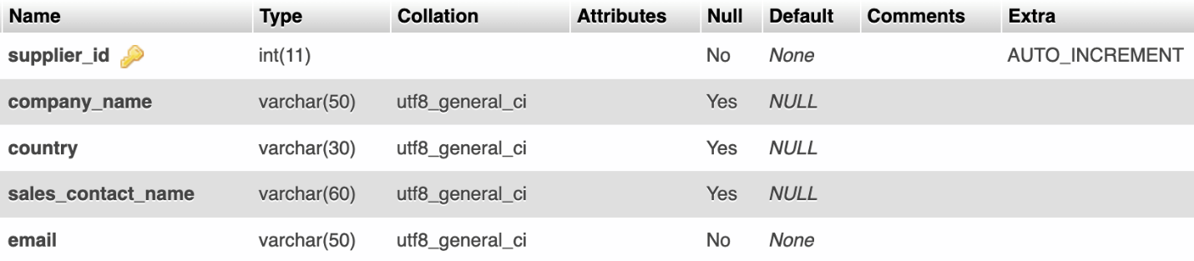  
SQL:*** CREATE TABLE `Supplier` (

`supplier_id` int(11) NOT NULL,

`company_name` varchar(50) DEFAULT NULL,

`country` varchar(30) DEFAULT NULL,

`sales_contact_name` varchar(60) DEFAULT NULL,

`email` varchar(50) NOT NULL

) ALTER TABLE `Supplier`

ADD PRIMARY KEY (`supplier_id`);

ALTER TABLE `Supplier`

MODIFY `supplier_id` int(11) NOT NULL AUTO_INCREMENT;

***INSERTION***

***COFFEE SHOP:***[INSERT](http://localhost:8888/phpMyAdmin5/url.php?url=https://dev.mysql.com/doc/refman/5.7/en/insert.html) INTO Coffee_Shop [VALUES](http://localhost:8888/phpMyAdmin5/url.php?url=https://dev.mysql.com/doc/refman/5.7/en/miscellaneous-functions.html#function_values) (223,'Starbucks','Orlando','FL'), (324,'Dunkin','New York','NY'), (789,'FoxTail inc.','Winter Park','FL')

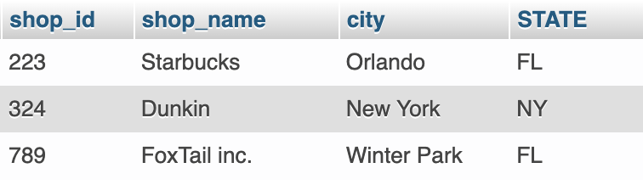

***SUPPLIER:***

[INSERT](http://localhost:8888/phpMyAdmin5/url.php?url=https://dev.mysql.com/doc/refman/5.7/en/insert.html) INTO Supplier [VALUES](http://localhost:8888/phpMyAdmin5/url.php?url=https://dev.mysql.com/doc/refman/5.7/en/miscellaneous-functions.html#function_values) (1,'Incredible Flavors','USA','Ralph Joseph','Ralph.Joseph@IncredFlav.com'), (2,'Ludlow Coffee Supply','USA','Tiffany Walker','tWalker@ludlow.com'), (3,'T.M. Ward Coffee','New Jersey','Courtney Wagner','Cwagner@WardCoffee.com')

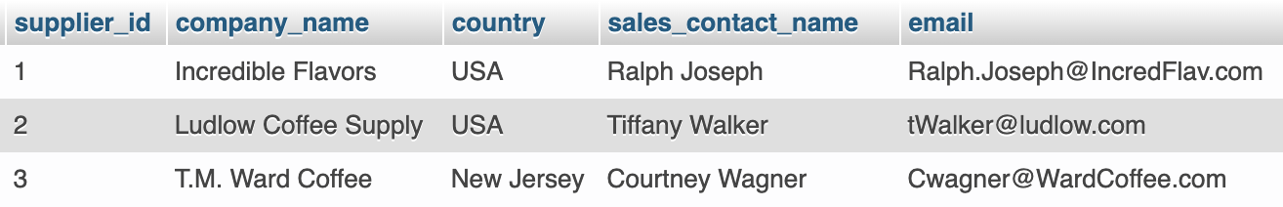

***EMPLOYEE:***

[INSERT](http://localhost:8888/phpMyAdmin5/url.php?url=https://dev.mysql.com/doc/refman/5.7/en/insert.html) INTO Employee [VALUES](http://localhost:8888/phpMyAdmin5/url.php?url=https://dev.mysql.com/doc/refman/5.7/en/miscellaneous-functions.html#function_values) (42,'Jason','Joseph','2012-11-21','Manager',789), (53,'Paul','Vector','2014-06-11','Assistant Manager',324), (81,'Juan','Del Tora','2017-05-01','Barista',223)

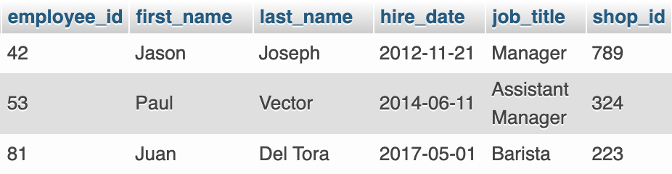

***COFFEE:***

[INSERT](http://localhost:8888/phpMyAdmin5/url.php?url=https://dev.mysql.com/doc/refman/5.7/en/insert.html) INTO Coffee [VALUES](http://localhost:8888/phpMyAdmin5/url.php?url=https://dev.mysql.com/doc/refman/5.7/en/miscellaneous-functions.html#function_values) (13,223,2,'Supreme Blend','13.75'), (40,223,2,'Coco Dream','11.25'), (24,324,3,'French Delight','9.75')

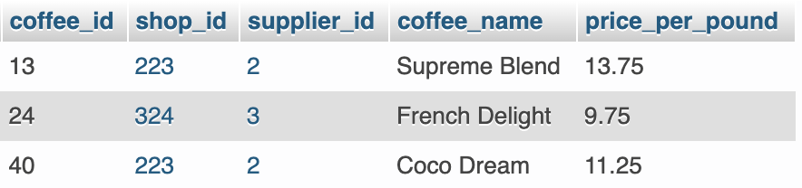

***View:***

***Complex Queries, Etc.:***

***2b.***

***3a.***

CREATE VIEW employee_view

AS SELECT employee_id,CONCAT(first_name,' ',last_name) AS employee_full_name, hire_date,

job_title,shop_id

FROM Employee;

CREATE VIEW employee_view

AS SELECT employee_id,CONCAT(first_name,' ',last_name) AS employee_full_name, hire_date,

job_title,shop_id

FROM Employee;

CREATE VIEW employee_view AS SELECT employee_id,CONCAT(first_name,' ',last_name) AS employee_full_name, hire_date, job_title,shop_id FROM Employee;

***3b.***

***4a.***

CREATE INDEX idx_coffee_name ON Coffee (coffee_name);

***4b.***

***5a.***

SELECT shop_name AS Shop, CONCAT(city, ', ',state) AS Location FROM Coffee_Shop WHERE state IN ('HI','CO');

***5b.***

***6a.***

SELECT Coffee_Shop.shop_name, Coffee.coffee_name, Coffee.price_per_pound, Supplier.company_name, Supplier.sales_contact_name, Supplier.emailFROM Coffee JOIN Coffee_Shop ON Coffee_Shop.shop_id = Coffee.shop_id JOIN Supplier ON Supplier.supplier_id = Coffee.supplier_id;

***6b.***

CREATE VIEW employee_view

AS SELECT employee_id,CONCAT(first_name,' ',last_name) AS employee_full_name, hire_date,

job_title,shop_id

FROM Employee;

CREATE VIEW employee_view

AS SELECT employee_id,CONCAT(first_name,' ',last_name) AS employee_full_name, hire_date,

job_title,shop_id

FROM Employee;

CREATE VIEW employee_view

AS SELECT employee_id,CONCAT(first_name,' ',last_name) AS employee_full_name, hire_date,

job_title,shop_id

FROM Employee;